**Vivekanand Education Society’s Institute**

**Of Information Technology**

Collector Colony, Kurla (East),

Mumbai – 400074, Tel: 91-22-261532532



**A Project Report**

**On**

**“Car Sales System”**

**Submitted By**

**Ninad Patil (Roll No 33)**

**Sarath Shankaranarayanan (Roll No 41)**



**(Java Programming And Unified Modelling Language Lab)**

**MINI PROJECT**

**CERTIFICATE**

This Mini Project duly signed in this Documentation represents the bonafide works by:

**NAME: NINAD A PATIL ROLL NO: 33**

**NAME: SARATH SHANKARANARAYANAN ROLL NO: 41**

For SEMESTER – III of Second Year of the Master in Computer Application (MCA) [Afternoon Shift] during the academic year 2020 – 2021.

**Lecturer In-Charge Head, Department of MCA**

**Lab Incharge External Examiner**

**ACKNOWLEGEMENT**

It is in good fortune that we find the opportunity to express our deep sense of gratitude to all those people who helped us with their guidance and assistance without which this project would not be possible.

The successful completion of any task would be incomplete without the mention of those people whose cooperation made it possible, whose constant guidance and encouragement crown all our efforts with success.

We would like to give our heartiest thanks to the Project guide, **Prof. SUNNY NAHAR, Prof. VAISHALI GATTY, AND Prof. KAJAL JEWANI** giving us their precious time, incessant encouragement, and for his valuable advice and guidance without which this project would not have seen the light of day.

We also thank our group members and colleagues who have helped in the successful completion of this project. And last but not least, we would like to thank all those who contributed to this project either morally or materially. Thank you all.

**INDEX**

|  |  |  |
| --- | --- | --- |
| **Sr. No** | **Topic** | **Remark** |
| 1 | Abstract |  |
| 2 | Existing System |  |
| 3 | Proposed System |  |
| 4 | Purpose of the System |  |
| 5 | Hardware/Software Specifications |  |
| 6 | UML diagrams |  |
| 7 | Project Screenshot and Code |  |
| 8 | Future Scope |  |
| 9 | Conclusion |  |
| 10 | Bibliography |  |

**ABSTRACT**

“Car Sales System” is a project which will keep all the records of the cars such as adding car details, editing details and deleting details. This project can be used at any cars showroom as we know it is not possible to keep so many records of cars and its specifications such as price, manufactured years, etc. This project manages very smoothly from keeping the records of all the car details. Since all the data is stored in the database such as adding car records, editing records and deleting the car details. This system can save lots of time in managing and editing car records and it also create less chaos and function very smoothly.

The main objective of the Car Sales System is to manage the details of cars. It is an application that computerizes the conventional of car sales procedure which we are aware of. This is a windows-based application which helps in managing data related to the buyers and sellers of the cars. It manages all the information about car manufactures and prices. The project is totally built at administrative end and thus only the administrator is guaranteed the access. The purpose of the project is to build an application program to reduce the manual work for managing the cars information. It tracks all the details about car manufacture, years, model, price, kilometre travelled and any extra information’s. The existing system carries more time to do a piece of work for this reason the Car Sales System is implemented.

**EXISTING SYSTEM**

There is hardly any proper smooth system is available for now to maintain the records of cars, as no proper records are available which leads to much chaos and time consuming. If the sales manager needs to know the details of cars before customers ask them and he don’t have a proper record of it, this will leas to mismanagement and lack of maintaining large records. Most of car showroom managements currently use a manual system for the management and maintenance of car information. The current system requires numerous paper forms, with data stores spread throughout the car showroom infrastructure. Often information is incomplete or does not follow management standards. Multiple copies of the same information exist in car showroom and may lead to inconsistencies in data in various data stores. The customers have to wait for long time to get the proper details of cars and it will waste lot of time in finding the data.

**PROPOSED SYSTEM**

This system will make the entire process very smooth and efficient with just a click of help. This system will maintain all sorts of data like adding, editing and deleting car records so it will be easy to allocated the car information’s.

This application mainly consists of 4 modules:

* Admin module
* Add module
* Edit module
* Delete module.

**Admin Module:** This module is purely admin of this application. In this the admin can add, edit, view and delete the records of car details.

**Add Module:** In add module the admin can add car records such as car manufacture, car year, car model, car price, kilometer travelled and any extra information’s.

**Edit Module:** In edit module the admin can edit car records depends on changes of the car such as kilometer travelled or price or any extra information’s.

**Delete Module:** In delete module the admin can delete the record of the car if the car has been purchased by the customers and has been transferred to any other showroom.

**PURPOSE OF THE SYSTEM**

* All the records and data have been computerized and are now persistent.
* Access to all types of records made easy.
* Manage the information of records.
* This system is User-friendly, interactive and easy to use.
* It has the capacity of storing huge data and keeping it safe.
* Save excess paper work.
* Avoiding confusion, data getting misplaced, time saving and no complexities.
* Data security facility.
* Easy navigation through the records is provided.
* Provides security to data through authorization.

**HARDWARE/SOFTWARE SPECIFICATIONS**

**HARDWARE REQUIREMENT**

* Intel(R) Core (TM) i5-4440 CPU @ 3.10GHz
* 4 GB DDR3 RAM.
* 10 GB Hard Disk

**SOFTWARE REQUIREMENT:**

* **Operating System:** Windows 7, Windows 8
* **Software Used:** NetBeans, Xampp and MS Word
* **Programming Language:** Java, AWT, Swing and JBDC

**UML DIAGRAMS**

**USE CASE DIAGRAM**

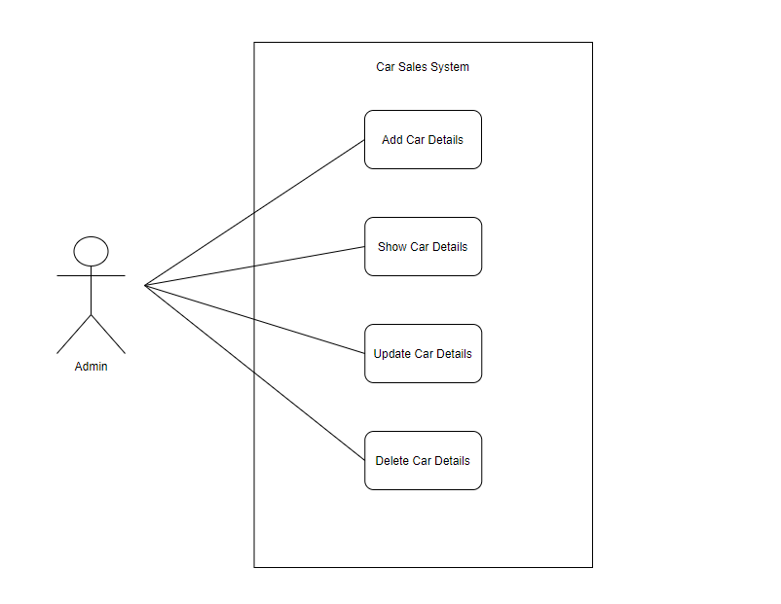

**CLASS DIAGRAM**

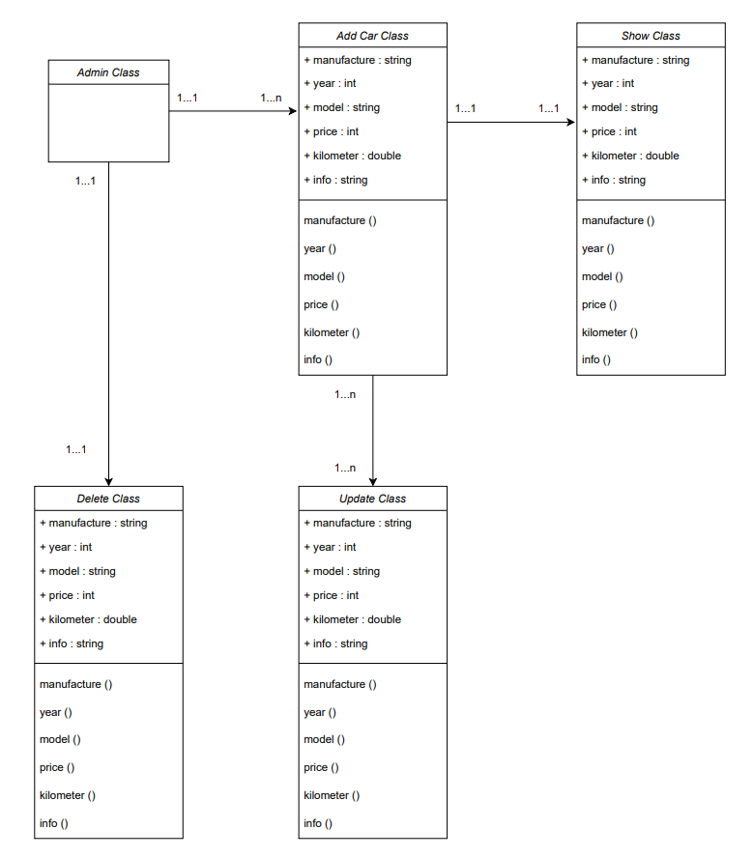

**ACTIVITY DIAGRAM**

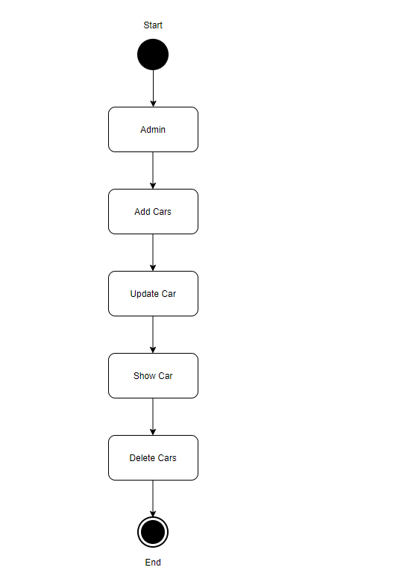

**OBJECT DIAGRAM**

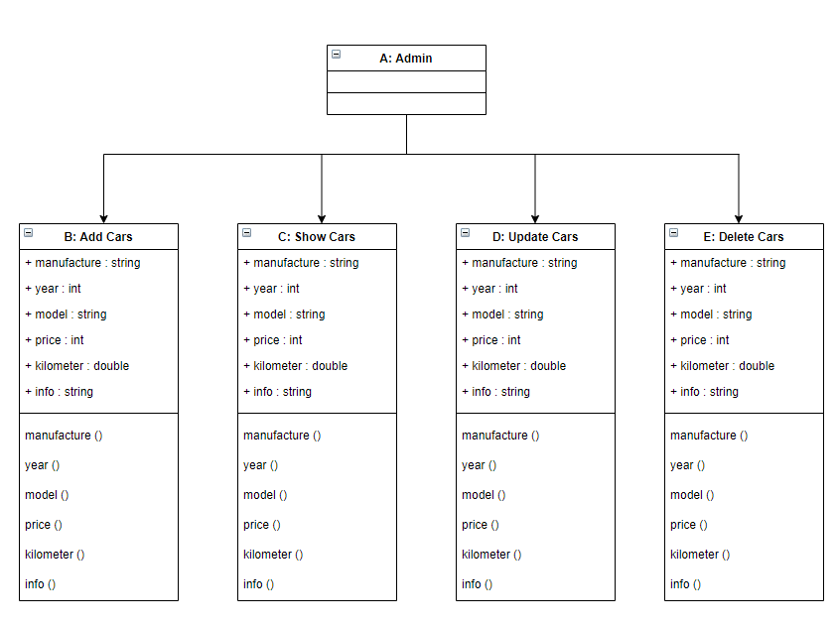

**COMPONENT DIAGRAM**

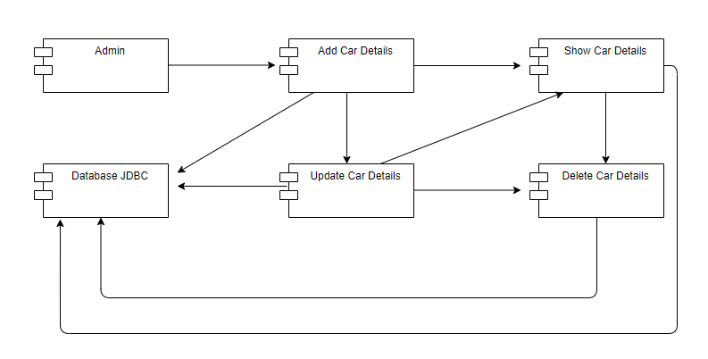

**CODING**

**login.java**

/*

* To change this license header, choose License Headers in Project Properties.

* To change this template file, choose Tools | Templates

* and open the template in the editor.

*/

package carsal;

import java.sql.Connection;

import java.sql.DriverManager;

import java.sql.PreparedStatement;

import java.sql.ResultSet;

import java.sql.SQLException;

import java.util.logging.Level;

import java.util.logging.Logger;

import javax.swing.JOptionPane;

public class login extends javax.swing.JFrame {

/**

* Creates new form login

*/

public login() {

initComponents();

}

/**

* This method is called from within the constructor to initialize the form.

* WARNING: Do NOT modify this code. The content of this method is always

* regenerated by the Form Editor.

*/

@SuppressWarnings("unchecked")

// <editor-fold defaultstate="collapsed" desc="Generated Code">

private void initComponents() {

jPanel1 = new javax.swing.JPanel();

un = new javax.swing.JTextField();

pass = new javax.swing.JPasswordField();

jLabel1 = new javax.swing.JLabel();

jLabel2 = new javax.swing.JLabel();

jButton1 = new javax.swing.JButton();

jButton2 = new javax.swing.JButton();

setDefaultCloseOperation(javax.swing.WindowConstants.EXIT_ON_CLOSE);

jPanel1.setBorder(javax.swing.BorderFactory.createLineBorder(new java.awt.Color(255, 0, 51), 20));

jLabel1.setText("Username");

jLabel2.setText("Password");

jButton1.setText("SIGNIN");

jButton1.addActionListener(new java.awt.event.ActionListener() {

public void actionPerformed(java.awt.event.ActionEvent evt) {

jButton1ActionPerformed(evt);

}

});

jButton2.setText("CANCEL");

jButton2.addActionListener(new java.awt.event.ActionListener() {

public void actionPerformed(java.awt.event.ActionEvent evt) {

jButton2ActionPerformed(evt);

}

});

javax.swing.GroupLayout jPanel1Layout = new javax.swing.GroupLayout(jPanel1);

jPanel1.setLayout(jPanel1Layout);

jPanel1Layout.setHorizontalGroup(

jPanel1Layout.createParallelGroup(javax.swing.GroupLayout.Alignment.LEADING)

.addGroup(javax.swing.GroupLayout.Alignment.TRAILING, jPanel1Layout.createSequentialGroup()

.addContainerGap(javax.swing.GroupLayout.DEFAULT_SIZE, Short.MAX_VALUE)

.addGroup(jPanel1Layout.createParallelGroup(javax.swing.GroupLayout.Alignment.LEADING, false)

.addComponent(jLabel1, javax.swing.GroupLayout.DEFAULT_SIZE, 127, Short.MAX_VALUE)

.addComponent(jLabel2, javax.swing.GroupLayout.DEFAULT_SIZE, javax.swing.GroupLayout.DEFAULT_SIZE, Short.MAX_VALUE))

.addGap(73, 73, 73)

.addGroup(jPanel1Layout.createParallelGroup(javax.swing.GroupLayout.Alignment.LEADING)

.addComponent(pass, javax.swing.GroupLayout.PREFERRED_SIZE, 112, javax.swing.GroupLayout.PREFERRED_SIZE)

.addComponent(un, javax.swing.GroupLayout.PREFERRED_SIZE, 112, javax.swing.GroupLayout.PREFERRED_SIZE))

.addGap(290, 290, 290))

.addGroup(jPanel1Layout.createSequentialGroup()

.addGap(377, 377, 377)

.addComponent(jButton1, javax.swing.GroupLayout.PREFERRED_SIZE, 76, javax.swing.GroupLayout.PREFERRED_SIZE)

.addGap(71, 71, 71)

.addComponent(jButton2, javax.swing.GroupLayout.PREFERRED_SIZE, 81, javax.swing.GroupLayout.PREFERRED_SIZE)

.addContainerGap(224, Short.MAX_VALUE))

);

jPanel1Layout.setVerticalGroup(

jPanel1Layout.createParallelGroup(javax.swing.GroupLayout.Alignment.LEADING)

.addGroup(jPanel1Layout.createSequentialGroup()

.addGroup(jPanel1Layout.createParallelGroup(javax.swing.GroupLayout.Alignment.LEADING)

.addGroup(jPanel1Layout.createSequentialGroup()

.addGap(34, 34, 34)

.addComponent(jLabel1, javax.swing.GroupLayout.PREFERRED_SIZE, 112, javax.swing.GroupLayout.PREFERRED_SIZE))

.addGroup(jPanel1Layout.createSequentialGroup()

.addGap(92, 92, 92)

.addComponent(un, javax.swing.GroupLayout.PREFERRED_SIZE, javax.swing.GroupLayout.DEFAULT_SIZE, javax.swing.GroupLayout.PREFERRED_SIZE)))

.addGroup(jPanel1Layout.createParallelGroup(javax.swing.GroupLayout.Alignment.LEADING)

.addGroup(jPanel1Layout.createSequentialGroup()

.addGap(63, 63, 63)

.addComponent(pass, javax.swing.GroupLayout.PREFERRED_SIZE, javax.swing.GroupLayout.DEFAULT_SIZE, javax.swing.GroupLayout.PREFERRED_SIZE))

.addGroup(jPanel1Layout.createSequentialGroup()

.addPreferredGap(javax.swing.LayoutStyle.ComponentPlacement.RELATED)

.addComponent(jLabel2, javax.swing.GroupLayout.PREFERRED_SIZE, 100, javax.swing.GroupLayout.PREFERRED_SIZE)))

.addPreferredGap(javax.swing.LayoutStyle.ComponentPlacement.RELATED, 59, Short.MAX_VALUE)

.addGroup(jPanel1Layout.createParallelGroup(javax.swing.GroupLayout.Alignment.BASELINE)

.addComponent(jButton1, javax.swing.GroupLayout.PREFERRED_SIZE, 32, javax.swing.GroupLayout.PREFERRED_SIZE)

.addComponent(jButton2, javax.swing.GroupLayout.PREFERRED_SIZE, 32, javax.swing.GroupLayout.PREFERRED_SIZE))

.addGap(52, 52, 52))

);

javax.swing.GroupLayout layout = new javax.swing.GroupLayout(getContentPane());

getContentPane().setLayout(layout);

layout.setHorizontalGroup(

layout.createParallelGroup(javax.swing.GroupLayout.Alignment.LEADING)

.addComponent(jPanel1, javax.swing.GroupLayout.DEFAULT_SIZE, javax.swing.GroupLayout.DEFAULT_SIZE, Short.MAX_VALUE)

);

layout.setVerticalGroup(

layout.createParallelGroup(javax.swing.GroupLayout.Alignment.LEADING)

.addComponent(jPanel1, javax.swing.GroupLayout.DEFAULT_SIZE, javax.swing.GroupLayout.DEFAULT_SIZE, Short.MAX_VALUE)

);

pack();

setLocationRelativeTo(null);

}// </editor-fold>

private void jButton1ActionPerformed(java.awt.event.ActionEvent evt) {

try {

// TODO add your handling code here:

Class.forName("com.mysql.jdbc.Driver");

Connection con =DriverManager.getConnection("jdbc:mysql://localhost/carsal","root","");

String sql ="Select * from login where username=? and password=?";

PreparedStatement pst =con.prepareStatement(sql);

pst.setString(1, un.getText());

pst.setString(2, pass.getText());

ResultSet rs = pst.executeQuery();

if(rs.next())

{

JOptionPane.showMessageDialog(null, "Login Success");

car car1 = new car();

car1.setVisible(true);

setVisible(false);

}

else

{

JOptionPane.showMessageDialog(null, "Username and password do not match");

un.setText("");

pass.setText("");

}

con.close();

}

catch(Exception e){

JOptionPane.showMessageDialog(null, e);

}

}

private void jButton2ActionPerformed(java.awt.event.ActionEvent evt) {

// TODO add your handling code here:

this.setVisible(false);

}

/**

* @param args the command line arguments

*/

public static void main(String args[]) {

/* Set the Nimbus look and feel */

//<editor-fold defaultstate="collapsed" desc=" Look and feel setting code (optional) ">

/* If Nimbus (introduced in Java SE 6) is not available, stay with the default look and feel.

* For details see http://download.oracle.com/javase/tutorial/uiswing/lookandfeel/plaf.html

*/

try {

for (javax.swing.UIManager.LookAndFeelInfo info : javax.swing.UIManager.getInstalledLookAndFeels()) {

if ("Nimbus".equals(info.getName())) {

javax.swing.UIManager.setLookAndFeel(info.getClassName());

break;

}

}

} catch (ClassNotFoundException ex) {

java.util.logging.Logger.getLogger(login.class.getName()).log(java.util.logging.Level.SEVERE, null, ex);

} catch (InstantiationException ex) {

java.util.logging.Logger.getLogger(login.class.getName()).log(java.util.logging.Level.SEVERE, null, ex);

} catch (IllegalAccessException ex) {

java.util.logging.Logger.getLogger(login.class.getName()).log(java.util.logging.Level.SEVERE, null, ex);

} catch (javax.swing.UnsupportedLookAndFeelException ex) {

java.util.logging.Logger.getLogger(login.class.getName()).log(java.util.logging.Level.SEVERE, null, ex); } //</editor-fold>

/* Create and display the form */

java.awt.EventQueue.invokeLater(new Runnable() {

public void run() {

new login().setVisible(true); } }); }

// Variables declaration - do not modify

private javax.swing.JButton jButton1;

private javax.swing.JButton jButton2;

private javax.swing.JLabel jLabel1;

private javax.swing.JLabel jLabel2;

private javax.swing.JPanel jPanel1;

private javax.swing.JPasswordField pass;

private javax.swing.JTextField un;

// End of variables declaration

}

**car.java**

/*

* To change this license header, choose License Headers in Project Properties.

* To change this template file, choose Tools | Templates

* and open the template in the editor.

*/

package carsal;

import java.sql.Connection;

import java.sql.DriverManager;

import java.sql.PreparedStatement;

import java.sql.ResultSet;

import java.sql.ResultSetMetaData;

import java.sql.SQLException;

import java.util.Vector;

import java.util.logging.Level;

import java.util.logging.Logger;

import javax.swing.JOptionPane;

import javax.swing.table.DefaultTableModel;

public class car extends javax.swing.JFrame {

/**

* Creates new form car

*/

public car() {

initComponents();

Connect();

load();

}

Connection con;

PreparedStatement pst;

DefaultTableModel df;

public void Connect()

{

try {

Class.forName("com.mysql.jdbc.Driver");

con=DriverManager.getConnection("jdbc:mysql://localhost/carsal","root","");

} catch (ClassNotFoundException ex) {

Logger.getLogger(car.class.getName()).log(Level.SEVERE, null, ex);

} catch (SQLException ex) {

Logger.getLogger(car.class.getName()).log(Level.SEVERE, null, ex);

}

}

public void load()

{

try {

pst=con.prepareStatement("select * from registration");

ResultSet rs= pst.executeQuery();

ResultSetMetaData rss=rs.getMetaData();

int c;

c=rss.getColumnCount();

df= (DefaultTableModel) jTable1.getModel();

df.setRowCount(0);

while(rs.next())

{

Vector v2 = new Vector();

for(int a=1;a<=c;a++)

{

v2.add(rs.getString("id"));

v2.add(rs.getString("manufacture"));

v2.add(rs.getString("year"));

v2.add(rs.getString("model"));

v2.add(rs.getString("price"));

v2.add(rs.getString("km"));

v2.add(rs.getString("info"));

}

df.addRow(v2);

}

} catch (SQLException ex) {

Logger.getLogger(car.class.getName()).log(Level.SEVERE, null, ex);

}

}

/**

* This method is called from within the constructor to initialize the form.

* WARNING: Do NOT modify this code. The content of this method is always

* regenerated by the Form Editor.

*/

@SuppressWarnings("unchecked")

// <editor-fold defaultstate="collapsed" desc="Generated Code">

private void initComponents() {

jPanel1 = new javax.swing.JPanel();

jLabel1 = new javax.swing.JLabel();

jPanel2 = new javax.swing.JPanel();

jLabel2 = new javax.swing.JLabel();

jLabel3 = new javax.swing.JLabel();

jLabel4 = new javax.swing.JLabel();

jLabel5 = new javax.swing.JLabel();

jLabel6 = new javax.swing.JLabel();

jLabel7 = new javax.swing.JLabel();

txtmanu = new javax.swing.JTextField();

txtyear = new javax.swing.JTextField();

txtmodel = new javax.swing.JTextField();

txtprice = new javax.swing.JTextField();

txtkm = new javax.swing.JTextField();

jScrollPane1 = new javax.swing.JScrollPane();

txtinfo = new javax.swing.JTextArea();

jButton1 = new javax.swing.JButton();

jButton2 = new javax.swing.JButton();

jButton3 = new javax.swing.JButton();

jButton4 = new javax.swing.JButton();

jScrollPane2 = new javax.swing.JScrollPane();

jTable1 = new javax.swing.JTable();

setDefaultCloseOperation(javax.swing.WindowConstants.EXIT_ON_CLOSE);

jPanel1.setBackground(new java.awt.Color(0, 0, 204));

jLabel1.setFont(new java.awt.Font("Tahoma", 1, 24)); // NOI18N

jLabel1.setForeground(new java.awt.Color(255, 255, 0));

jLabel1.setText("CAR SALES");

javax.swing.GroupLayout jPanel1Layout = new javax.swing.GroupLayout(jPanel1);

jPanel1.setLayout(jPanel1Layout);

jPanel1Layout.setHorizontalGroup(

jPanel1Layout.createParallelGroup(javax.swing.GroupLayout.Alignment.LEADING)

.addGroup(javax.swing.GroupLayout.Alignment.TRAILING, jPanel1Layout.createSequentialGroup()

.addContainerGap(592, Short.MAX_VALUE)

.addComponent(jLabel1)

.addGap(560, 560, 560))

);

jPanel1Layout.setVerticalGroup(

jPanel1Layout.createParallelGroup(javax.swing.GroupLayout.Alignment.LEADING)

.addGroup(javax.swing.GroupLayout.Alignment.TRAILING, jPanel1Layout.createSequentialGroup()

.addContainerGap(28, Short.MAX_VALUE)

.addComponent(jLabel1)

.addGap(24, 24, 24))

);

jPanel2.setBorder(javax.swing.BorderFactory.createTitledBorder(null, "Registration", javax.swing.border.TitledBorder.DEFAULT_JUSTIFICATION, javax.swing.border.TitledBorder.DEFAULT_POSITION, new java.awt.Font("Tahoma", 1, 18))); // NOI18N

jLabel2.setFont(new java.awt.Font("Tahoma", 1, 14)); // NOI18N

jLabel2.setText("Manufacture");

jLabel3.setFont(new java.awt.Font("Tahoma", 1, 14)); // NOI18N

jLabel3.setText("Year");

jLabel4.setFont(new java.awt.Font("Tahoma", 1, 14)); // NOI18N

jLabel4.setText("Model");

jLabel5.setFont(new java.awt.Font("Tahoma", 1, 14)); // NOI18N

jLabel5.setText("Price");

jLabel6.setFont(new java.awt.Font("Tahoma", 1, 14)); // NOI18N

jLabel6.setText("KM Travel");

jLabel7.setFont(new java.awt.Font("Tahoma", 1, 14)); // NOI18N

jLabel7.setText("Extra Info");

txtinfo.setColumns(20);

txtinfo.setRows(5);

jScrollPane1.setViewportView(txtinfo);

jButton1.setText("ADD");

jButton1.addActionListener(new java.awt.event.ActionListener() {

public void actionPerformed(java.awt.event.ActionEvent evt) {

jButton1ActionPerformed(evt);

}

});

jButton2.setText("EDIT");

jButton2.addActionListener(new java.awt.event.ActionListener() {

public void actionPerformed(java.awt.event.ActionEvent evt) {

jButton2ActionPerformed(evt);

}

});

jButton3.setText("DELETE");

jButton3.addActionListener(new java.awt.event.ActionListener() {

public void actionPerformed(java.awt.event.ActionEvent evt) {

jButton3ActionPerformed(evt);

}

});

jButton4.setText("CANCEL");

jButton4.addActionListener(new java.awt.event.ActionListener() {

public void actionPerformed(java.awt.event.ActionEvent evt) {

jButton4ActionPerformed(evt);

}

});

javax.swing.GroupLayout jPanel2Layout = new javax.swing.GroupLayout(jPanel2);

jPanel2.setLayout(jPanel2Layout);

jPanel2Layout.setHorizontalGroup(

jPanel2Layout.createParallelGroup(javax.swing.GroupLayout.Alignment.LEADING)

.addGroup(javax.swing.GroupLayout.Alignment.TRAILING, jPanel2Layout.createSequentialGroup()

.addContainerGap() .addGroup(jPanel2Layout.createParallelGroup(javax.swing.GroupLayout.Alignment.TRAILING)

.addGroup(jPanel2Layout.createSequentialGroup()

.addGroup(jPanel2Layout.createParallelGroup(javax.swing.GroupLayout.Alignment.LEADING, false)

.addGroup(jPanel2Layout.createSequentialGroup()

.addGroup(jPanel2Layout.createParallelGroup(javax.swing.GroupLayout.Alignment.LEADING)

.addComponent(jLabel7)

.addComponent(jLabel6))

.addGroup(jPanel2Layout.createParallelGroup(javax.swing.GroupLayout.Alignment.LEADING)

.addGroup(jPanel2Layout.createSequentialGroup()

.addGap(39, 39, 39)

.addComponent(jScrollPane1, javax.swing.GroupLayout.PREFERRED_SIZE, javax.swing.GroupLayout.DEFAULT_SIZE, javax.swing.GroupLayout.PREFERRED_SIZE))

.addGroup(javax.swing.GroupLayout.Alignment.TRAILING, jPanel2Layout.createSequentialGroup()

.addGap(49, 49, 49)

.addComponent(txtkm, javax.swing.GroupLayout.PREFERRED_SIZE, 156, javax.swing.GroupLayout.PREFERRED_SIZE))))

.addGroup(jPanel2Layout.createSequentialGroup()

.addComponent(jLabel2)

.addGap(33, 33, 33)

.addComponent(txtmanu, javax.swing.GroupLayout.PREFERRED_SIZE, 156, javax.swing.GroupLayout.PREFERRED_SIZE))

.addGroup(jPanel2Layout.createSequentialGroup()

.addComponent(jLabel3)

.addGap(89, 89, 89)

.addComponent(txtyear, javax.swing.GroupLayout.PREFERRED_SIZE, 156, javax.swing.GroupLayout.PREFERRED_SIZE))

.addGroup(jPanel2Layout.createSequentialGroup()

.addComponent(jLabel4)

.addGap(79, 79, 79)

.addComponent(txtmodel, javax.swing.GroupLayout.PREFERRED_SIZE, 156, javax.swing.GroupLayout.PREFERRED_SIZE))

.addGroup(jPanel2Layout.createSequentialGroup()

.addComponent(jLabel5)

.addGap(87, 87, 87)

.addComponent(txtprice)))

.addPreferredGap(javax.swing.LayoutStyle.ComponentPlacement.RELATED, 226, Short.MAX_VALUE)

.addGroup(jPanel2Layout.createParallelGroup(javax.swing.GroupLayout.Alignment.LEADING)

.addComponent(jButton3, javax.swing.GroupLayout.Alignment.TRAILING, javax.swing.GroupLayout.PREFERRED_SIZE, 96, javax.swing.GroupLayout.PREFERRED_SIZE)

.addComponent(jButton4, javax.swing.GroupLayout.Alignment.TRAILING, javax.swing.GroupLayout.PREFERRED_SIZE, 96, javax.swing.GroupLayout.PREFERRED_SIZE)))

.addGroup(jPanel2Layout.createSequentialGroup()

.addGap(0, 0, Short.MAX_VALUE)

.addGroup(jPanel2Layout.createParallelGroup(javax.swing.GroupLayout.Alignment.TRAILING)

.addComponent(jButton2, javax.swing.GroupLayout.PREFERRED_SIZE, 96, javax.swing.GroupLayout.PREFERRED_SIZE)

.addComponent(jButton1, javax.swing.GroupLayout.PREFERRED_SIZE, 96, javax.swing.GroupLayout.PREFERRED_SIZE))))

.addGap(70, 70, 70))

);

jPanel2Layout.setVerticalGroup(

jPanel2Layout.createParallelGroup(javax.swing.GroupLayout.Alignment.LEADING)

.addGroup(jPanel2Layout.createSequentialGroup()

.addGap(37, 37, 37)

.addGroup(jPanel2Layout.createParallelGroup(javax.swing.GroupLayout.Alignment.TRAILING)

.addGroup(jPanel2Layout.createSequentialGroup()

.addGroup(jPanel2Layout.createParallelGroup(javax.swing.GroupLayout.Alignment.TRAILING)

.addGroup(jPanel2Layout.createSequentialGroup()

.addGroup(jPanel2Layout.createParallelGroup(javax.swing.GroupLayout.Alignment.BASELINE)

.addComponent(jLabel2)

.addComponent(txtmanu, javax.swing.GroupLayout.PREFERRED_SIZE, javax.swing.GroupLayout.DEFAULT_SIZE, javax.swing.GroupLayout.PREFERRED_SIZE))

.addGap(49, 49, 49)

.addComponent(jLabel3))

.addGroup(jPanel2Layout.createSequentialGroup()

.addComponent(jButton1, javax.swing.GroupLayout.PREFERRED_SIZE, 38, javax.swing.GroupLayout.PREFERRED_SIZE)

.addGap(2, 2, 2)

.addComponent(txtyear, javax.swing.GroupLayout.PREFERRED_SIZE, javax.swing.GroupLayout.DEFAULT_SIZE, javax.swing.GroupLayout.PREFERRED_SIZE)))

.addGroup(jPanel2Layout.createParallelGroup(javax.swing.GroupLayout.Alignment.LEADING, false)

.addGroup(jPanel2Layout.createSequentialGroup()

.addGap(48, 48, 48)

.addGroup(jPanel2Layout.createParallelGroup(javax.swing.GroupLayout.Alignment.TRAILING)

.addGroup(jPanel2Layout.createSequentialGroup()

.addComponent(jLabel4)

.addGap(45, 45, 45)

.addComponent(jLabel5))

.addGroup(jPanel2Layout.createSequentialGroup()

.addComponent(txtmodel, javax.swing.GroupLayout.PREFERRED_SIZE, javax.swing.GroupLayout.DEFAULT_SIZE, javax.swing.GroupLayout.PREFERRED_SIZE)

.addGap(39, 39, 39)

.addComponent(txtprice, javax.swing.GroupLayout.PREFERRED_SIZE, javax.swing.GroupLayout.DEFAULT_SIZE, javax.swing.GroupLayout.PREFERRED_SIZE)

.addGap(11, 11, 11))))

.addGroup(jPanel2Layout.createSequentialGroup()

.addGap(4, 4, 4)

.addComponent(jButton2, javax.swing.GroupLayout.PREFERRED_SIZE, 36, javax.swing.GroupLayout.PREFERRED_SIZE)

.addPreferredGap(javax.swing.LayoutStyle.ComponentPlacement.RELATED, javax.swing.GroupLayout.DEFAULT_SIZE, Short.MAX_VALUE)

.addComponent(jButton3, javax.swing.GroupLayout.PREFERRED_SIZE, 35, javax.swing.GroupLayout.PREFERRED_SIZE)

.addGap(21, 21, 21)))

.addGroup(jPanel2Layout.createParallelGroup(javax.swing.GroupLayout.Alignment.LEADING)

.addGroup(jPanel2Layout.createSequentialGroup()

.addGap(44, 44, 44)

.addComponent(jLabel6))

.addComponent(jButton4, javax.swing.GroupLayout.Alignment.TRAILING, javax.swing.GroupLayout.PREFERRED_SIZE, 37, javax.swing.GroupLayout.PREFERRED_SIZE)))

.addComponent(txtkm, javax.swing.GroupLayout.PREFERRED_SIZE, javax.swing.GroupLayout.DEFAULT_SIZE, javax.swing.GroupLayout.PREFERRED_SIZE))

.addGroup(jPanel2Layout.createParallelGroup(javax.swing.GroupLayout.Alignment.LEADING)

.addGroup(jPanel2Layout.createSequentialGroup()

.addGap(50, 50, 50)

.addComponent(jLabel7)

.addContainerGap(javax.swing.GroupLayout.DEFAULT_SIZE, Short.MAX_VALUE))

.addGroup(javax.swing.GroupLayout.Alignment.TRAILING, jPanel2Layout.createSequentialGroup()

.addPreferredGap(javax.swing.LayoutStyle.ComponentPlacement.RELATED, 42, Short.MAX_VALUE)

.addComponent(jScrollPane1, javax.swing.GroupLayout.PREFERRED_SIZE, javax.swing.GroupLayout.DEFAULT_SIZE, javax.swing.GroupLayout.PREFERRED_SIZE)

.addGap(63, 63, 63))))

);

jTable1.setModel(new javax.swing.table.DefaultTableModel(

new Object [][] {

},

new String [] {

"ID", "Manufacture", "Year", "Model", "Price", "KMTravel", "Info"

}

));

jTable1.addMouseListener(new java.awt.event.MouseAdapter() {

public void mouseClicked(java.awt.event.MouseEvent evt) {

jTable1MouseClicked(evt);

}

});

jScrollPane2.setViewportView(jTable1);

javax.swing.GroupLayout layout = new javax.swing.GroupLayout(getContentPane());

getContentPane().setLayout(layout);

layout.setHorizontalGroup(

layout.createParallelGroup(javax.swing.GroupLayout.Alignment.LEADING)

.addGroup(layout.createSequentialGroup()

.addComponent(jPanel1, javax.swing.GroupLayout.PREFERRED_SIZE, javax.swing.GroupLayout.DEFAULT_SIZE, javax.swing.GroupLayout.PREFERRED_SIZE)

.addGap(0, 0, Short.MAX_VALUE))

.addGroup(layout.createSequentialGroup()

.addContainerGap()

.addComponent(jPanel2, javax.swing.GroupLayout.PREFERRED_SIZE, javax.swing.GroupLayout.DEFAULT_SIZE, javax.swing.GroupLayout.PREFERRED_SIZE)

.addPreferredGap(javax.swing.LayoutStyle.ComponentPlacement.UNRELATED)

.addComponent(jScrollPane2)

.addContainerGap())

);

layout.setVerticalGroup(

layout.createParallelGroup(javax.swing.GroupLayout.Alignment.LEADING)

.addGroup(layout.createSequentialGroup()

.addComponent(jPanel1, javax.swing.GroupLayout.PREFERRED_SIZE, javax.swing.GroupLayout.DEFAULT_SIZE, javax.swing.GroupLayout.PREFERRED_SIZE)

.addGroup(layout.createParallelGroup(javax.swing.GroupLayout.Alignment.LEADING)

.addGroup(layout.createSequentialGroup()

.addPreferredGap(javax.swing.LayoutStyle.ComponentPlacement.RELATED)

.addComponent(jPanel2, javax.swing.GroupLayout.PREFERRED_SIZE, javax.swing.GroupLayout.DEFAULT_SIZE, javax.swing.GroupLayout.PREFERRED_SIZE)

.addGap(0, 0, Short.MAX_VALUE))

.addGroup(layout.createSequentialGroup()

.addGap(17, 17, 17)

.addComponent(jScrollPane2)))

.addGap(6, 6, 6))

);

pack();

setLocationRelativeTo(null);

}// </editor-fold>

private void jButton1ActionPerformed(java.awt.event.ActionEvent evt) {

try {

String manu,year,model,price,km,info;

manu=txtmanu.getText();

year=txtyear.getText();

model=txtmodel.getText();

price=txtprice.getText();

km=txtkm.getText();

info=txtinfo.getText();

pst = con.prepareStatement("insert into registration(manufacture,year,model,price,km,info)values(?,?,?,?,?,?)");

pst.setString(1, manu);

pst.setString(2, year);

pst.setString(3, model);

pst.setString(4, price);

pst.setString(5, km);

pst.setString(6, info);

pst.executeUpdate();

JOptionPane.showMessageDialog(this, "Record Added");

load();

txtmanu.setText("");

txtyear.setText("");

txtmodel.setText("");

txtprice.setText("");

txtkm.setText("");

txtinfo.setText("");

txtmanu.requestFocus();

} catch (SQLException ex) {

Logger.getLogger(car.class.getName()).log(Level.SEVERE, null, ex);

}

}

private void jTable1MouseClicked(java.awt.event.MouseEvent evt) {

// TODO add your handling code here:

df=(DefaultTableModel)jTable1.getModel();

int selected = jTable1.getSelectedRow();

int id= Integer.parseInt(df.getValueAt(selected, 0).toString());

txtmanu.setText(df.getValueAt(selected, 1).toString());

txtyear.setText(df.getValueAt(selected, 2).toString());

txtmodel.setText(df.getValueAt(selected, 3).toString());

txtprice.setText(df.getValueAt(selected, 4).toString());

txtkm.setText(df.getValueAt(selected, 5).toString());

txtinfo.setText(df.getValueAt(selected, 6).toString());

jButton1.setEnabled(false);

}

private void jButton2ActionPerformed(java.awt.event.ActionEvent evt) {

// TODO add your handling code here:

df=(DefaultTableModel)jTable1.getModel();

int selected = jTable1.getSelectedRow();

int id= Integer.parseInt(df.getValueAt(selected, 0).toString());

try {

String manu,year,model,price,km,info;

manu=txtmanu.getText();

year=txtyear.getText();

model=txtmodel.getText();

price=txtprice.getText();

km=txtkm.getText();

info=txtinfo.getText();

pst = con.prepareStatement("update registration set manufacture = ?,year = ?,model = ?,price = ?,km = ?,info = ? where id =? ");

pst.setString(1, manu);

pst.setString(2, year);

pst.setString(3, model);

pst.setString(4, price);

pst.setString(5, km);

pst.setString(6, info);

pst.setInt(7, id);

pst.executeUpdate();

JOptionPane.showMessageDialog(this, "Record Updated");

load();

jButton1.setEnabled(true);

txtmanu.setText("");

txtyear.setText("");

txtmodel.setText("");

txtprice.setText("");

txtkm.setText("");

txtinfo.setText("");

txtmanu.requestFocus();

} catch (SQLException ex) {

Logger.getLogger(car.class.getName()).log(Level.SEVERE, null, ex);

}

}

private void jButton3ActionPerformed(java.awt.event.ActionEvent evt) {

// TODO add your handling code here:

df=(DefaultTableModel)jTable1.getModel();

int selected = jTable1.getSelectedRow();

int id= Integer.parseInt(df.getValueAt(selected, 0).toString());

try {

pst = con.prepareStatement("delete from registration where id=? ");

pst.setInt(1, id);

pst.executeUpdate();

JOptionPane.showMessageDialog(this, "Record Deleted");

load();

jButton1.setEnabled(true);

txtmanu.setText("");

txtyear.setText("");

txtmodel.setText("");

txtprice.setText("");

txtkm.setText("");

txtinfo.setText("");

txtmanu.requestFocus();

} catch (SQLException ex) {

Logger.getLogger(car.class.getName()).log(Level.SEVERE, null, ex); } }

private void jButton4ActionPerformed(java.awt.event.ActionEvent evt) {

// TODO add your handling code here:

this.setVisible(false); }

/**

* @param args the command line arguments

*/

public static void main(String args[]) {

/* Set the Nimbus look and feel */

//<editor-fold defaultstate="collapsed" desc=" Look and feel setting code (optional) ">

/* If Nimbus (introduced in Java SE 6) is not available, stay with the default look and feel.

* For details see http://download.oracle.com/javase/tutorial/uiswing/lookandfeel/plaf.html

*/

try {

for (javax.swing.UIManager.LookAndFeelInfo info : javax.swing.UIManager.getInstalledLookAndFeels()) {

if ("Nimbus".equals(info.getName())) {

javax.swing.UIManager.setLookAndFeel(info.getClassName());

break; } }

} catch (ClassNotFoundException ex) {

java.util.logging.Logger.getLogger(car.class.getName()).log(java.util.logging.Level.SEVERE, null, ex);

} catch (InstantiationException ex) {

java.util.logging.Logger.getLogger(car.class.getName()).log(java.util.logging.Level.SEVERE, null, ex);

} catch (IllegalAccessException ex) {

java.util.logging.Logger.getLogger(car.class.getName()).log(java.util.logging.Level.SEVERE, null, ex);

} catch (javax.swing.UnsupportedLookAndFeelException ex) {

java.util.logging.Logger.getLogger(car.class.getName()).log(java.util.logging.Level.SEVERE, null, ex); } //</editor-fold>

/* Create and display the form */

java.awt.EventQueue.invokeLater(new Runnable() {

public void run() {

new car().setVisible(true); } }); }

// Variables declaration - do not modify

private javax.swing.JButton jButton1;

private javax.swing.JButton jButton2;

private javax.swing.JButton jButton3;

private javax.swing.JButton jButton4;

private javax.swing.JLabel jLabel1;

private javax.swing.JLabel jLabel2;

private javax.swing.JLabel jLabel3;

private javax.swing.JLabel jLabel4;

private javax.swing.JLabel jLabel5;

private javax.swing.JLabel jLabel6;

private javax.swing.JLabel jLabel7;

private javax.swing.JPanel jPanel1;

private javax.swing.JPanel jPanel2;

private javax.swing.JScrollPane jScrollPane1;

private javax.swing.JScrollPane jScrollPane2;

private javax.swing.JTable jTable1;

private javax.swing.JTextArea txtinfo;

private javax.swing.JTextField txtkm;

private javax.swing.JTextField txtmanu;

private javax.swing.JTextField txtmodel;

private javax.swing.JTextField txtprice;

private javax.swing.JTextField txtyear;

// End of variables declaration

}

**SCREENSHOTS**

**ADMIN LOGIN**

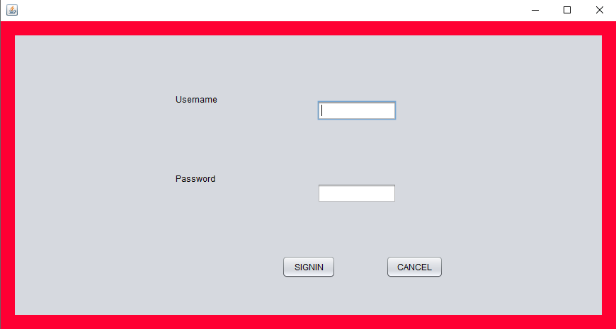

**ADD MODULE**

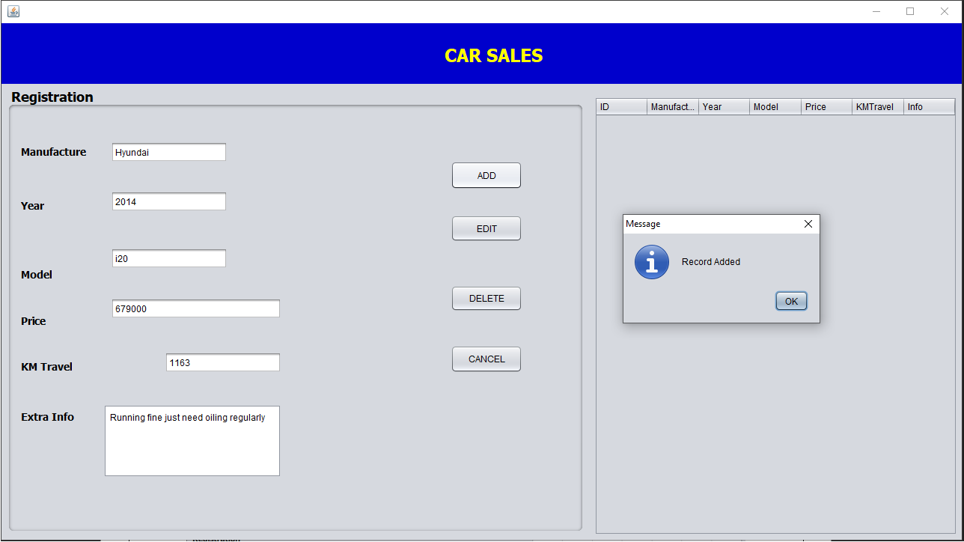

**EDIT MODULE**

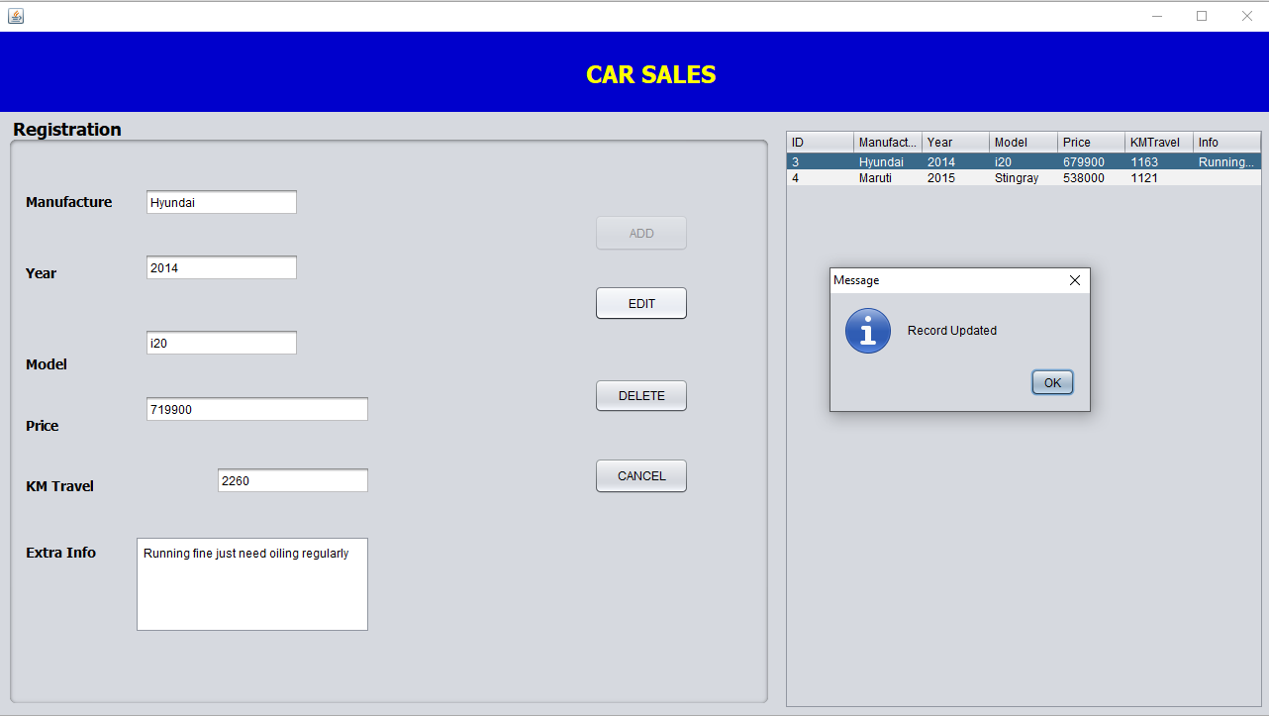

**DELETE MODULE**

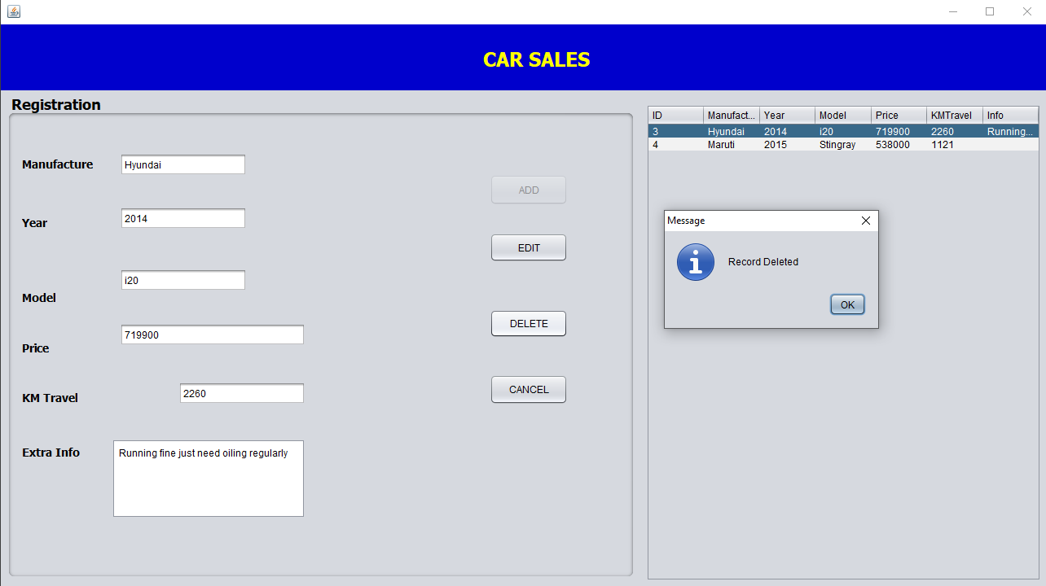

**DATABASE**

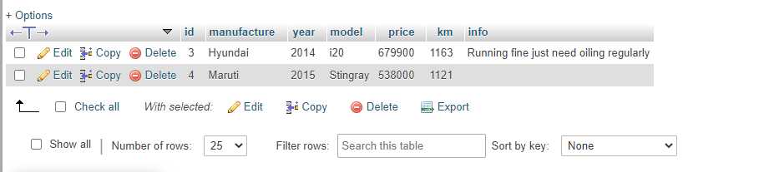

**FUTURE SCOPE**

A lot of features or functionalities can be added into this system such as searching of data, buying or selling of cars. Some more modules can also be added so as to better retrieve the car information details. This is not the overall description about the Car Sales System. Further enhancements can be made in designing the more screens. Some more design can also be added in the particular existing system.

**CONCLUSION**

Car Sales System is a customizable and user-friendly software designed for small showroom which has administrator module which can enter add car details, edit details and delete details. It has been designed to automate, manage and look after the overall processing of even very large data of cars. Car Sales System is offering a maximum stability, cost-effectiveness and usability. It provides the most flexible and adaptable standards for managing system software solutions for car showroom. The project can be expanded into a domain for reviews and comparing models of cars.

**Bibliography**

* Core Java Volume I Fundamentals, Cay S. Horstmann
* Effective Java, Joshua Bloch
* Java Performance: The Definite Guide, Scott Oaks
* Oracle JBDC, Donald Blake